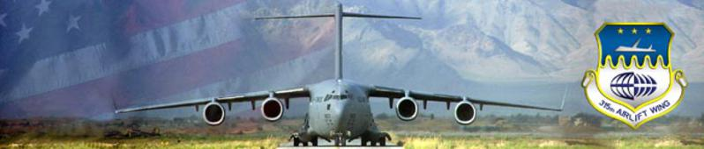
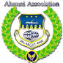
315th Airlift Wing Alumni Association
31 315th Airlift Wing Excellence over the Years
Joint Base Charleston, South Carolina

Visit our website at: http://www.315awaalumniassoc.com/

Upcoming events for the 315AW Alumni Association
The Octoberfest, sponsored by the 300AS, is scheduled for Saturday, 15 October 2022, from 5:00 pm - 9:00 pm at the home of Lt Colonel Barry Strauss, 4980 Lambs Road, Charleston, SC 29418.

Veterans Day Parade is scheduled for Sunday, 6 Nov 2022 from 1:00 pm - 4:00 pm. It will begin on Market and East Bay Streets and end at Colonel Lake. Staging will begin at 11:00 am. Alumni members who are interested in riding on a float should contact Col James Roberts at jroberts1952@msn.com.

The next 315AW Alumni board meeting will be held at 09:30 am and the luncheon 11:00 am on 2 Dec 2022.

James B. Roberts, Jr.
President
315AW Alumni Association

Steve Lewis, 300AS navigator from 1975 - 1981, has lost his 300th Squadron mug. He would really like to get a 300th Ad Astra mug if any are still being made and are available. He has looked online and can't find a source. Any help would be appreciated. Someone may be willing to give up theirs. stevelewis@pcisys.net
The Aerial Ports Squadrons held their monthly gathering and dinner on 3 Oct 2022 at O Charly's outside the Northwoods Mall on Rivers Avenue. These monthly get togethers have been going on for 27 years. Walter "Dick" Obrien is the point of contact. Dick is a current active member of the 315AW Alumni Association. He was assigned to the 38/51/81 APS. Dick gave me a roster of all his contacts. It's very long and I have not counted all the names yet. Dick says you just show up and eat. This is not an organization like the 315AW Alumni. Anyone may attend. I sat beside Chief Jacky Marks of the 51/38 APS. I recognized him immediately, as he is a current active member of the 315th Alumni Association. Jacky was our Treasurer and held that position longer than anyone on record. He was replaced by Chief Len Stempin. I will be attending all future dinners. The next one is scheduled for 7 November at 5:00 pm. There were 11 Aerial porters present at the 3 Oct dinner. I passed around a clip board and had everyone present jot down their name and email address. Many are members of the 315th Alumni and I hope to sign on many more.
Final Fly-by
MSgt Jimmy E. "Bones" Wilson, 315th Comm Squadron, passed on 1 January 2021 at the age of 75. Jimmy is survived by his loving wife Doris of 54 years. Jimmy was a 1964 graduate of Easley High School where he excelled in basketball. He attended Greenville College where he played basketball for the Mounties until being drafted by the US Army. He served during the Vietnam war. After his discharge, he joined the 315th Airlift Wing where he served over 27 years. He also served as Commander of the American Legion Post 52. He retired with Bell South with 33 years of service. Jimmy was currently an active member of the 315AW Alumni Association, dues paid in full.
Funeral services were held at Bushy Creek Baptist Church followed by burial at Robinson Memorial Gardens with full military honors provided by the Air Force Honor Guard.
RobinsonFuneralHomes.com http://robinsonfunerallhomes.com
Anticipation of death is worse than death it's self.
Steve Segall

Del Oxford, Communications

