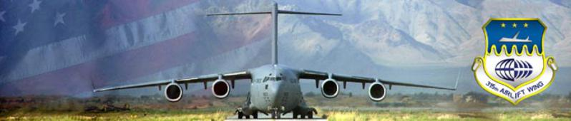
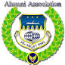
315th Airlift Wing Alumni Association
31 315th Airlift Wing Excellence over the Years
Joint Base Charleston, South Carolina

Visit our website at: http://www.315awaalumniassoc.com/

315AW Alumni Association Newsletter #12, 10 Aug 2023

You may view all past issues of the newsletters and more at our website.
http://www.315awaalumniassoc.com. Check it out.
Chief Tom Clemons, Webmaster

Carla Jameson, the spouse of SMSgt (ret) Robert W. Jameson of the 701/701 AS, passed on Saturday 15 July 2023. Funeral services were held at the Church of Jesus Christ of the Latter-Day Saints on Antler Drive, N. Charleston. If you wish to send flowers, you may send them to Carolina Memorial Gardens, 7113 Rivers Ave., N. Charleston 29406.

Final Fly By

MSgt (ret) Ernest "Ernie " G. Tomes, Air Force Reserve Recruiter, passed on 28 January 2011 at the age of 78. Ernie is survived by his spouse Elsie and she lives in their home in Summerville. I served in Recruiting Service about the same time frame as Ernie. At all our numerous gatherings and at our home, Ernie would always write lots of beautiful poetry. Ernie was a country boy from Kentucky and earned the title "dad burnet Earnie."

We were delighted to have Colonel John F. Robinson, the current 315th Wing Commander and his Command Chief Gonzalez attend our last 315th AW Alumni Board meeting.

The next board meeting will be held on Friday 8 Sept 2023 in building 60.

09:30 - 10:30, board meeting
10:30 - 11:00, setup
11:00 - 12:30, luncheon

Scientists made it official:
July was by far the hottest month on record according to today's local Post & Courier and the Associated Press.

I will visit my favorite watering hole today and have a few cool ones.

Stay cool.

Del Oxford, Communications

